Resources for Survivors of Gender-Based Violence

Before you read this document, please know that you are not alone. We believe you.
We have created this guide to share information and resources for survivors of sexual violence. This packet is intended to connect you with resources on- and off-campus to provide you with support and options. We know that this time in your life can be very stressful and that much of the language here may be triggering or upsetting. However, we also hope that you find this guide to be informative and empowering.
The person or department who gave you this packet is available to help you and can connect you to resources, advocacy, and assistance in reporting the assault if you choose to do so.
If you need to speak to someone right away, please call The Line at 773-494-3810 or the Chicago Rape Crisis Hotline at 888-293-2080.

Table of Contents

- Loyola Advocacy Services…………………………………………………………………..Page 3

- Tips and Techniques for Survivors……………………………………………………..Page 4

- What to Expect at the Emergency Room……………………………………………Page 7

- Sexual Assault Survivors Emergency Treatment Act, Crime Victim’s Compensation Act, Victims Economic Security and Safety Act……………Page 9

- Wellness Center Services…………………………………………………………………Page 11

- Loyola’ Policies Regarding Sexual Misconduct………………………………….Page 13

- Off-Campus Resources…………………………………………………………………….Page 14

Loyola Advocacy Services

The Wellness Center offers support and advocacy to students who have experienced gender-based violence, including sexual assault, sexual harassment, stalking, and intimate partner violence or domestic violence. Trained advocates are available to answer any questions that you may have. Confidential, nonjudgmental services include:
- Information about what resources exist on- and off-campus for counseling, support, and legal advocacy
- Education about medical options and procedures, including evidence collection
- Assistance in reporting assault to Campus Safety, if you choose
- Information about reporting and support in navigating Loyola's judicial process, if you choose
- Assistance in creating a safety plan
- Referrals to counseling and other supportive campus and community services
- Assistance for significant others, family, and friends of survivors
You have options, and you are not alone.
The primary way to connect with an advocate is to call The Line at Loyola at 773-494-3810. The Line is open Monday-Friday, 8:30am-5:00pm and 24 hours on the weekend when classes are in session. You can also use The Line to schedule an in person advocacy appointment.
Visit Loyola’s advocacy services webpage for more information. If The Line is closed and you would like to speak to someone right away, please call the Chicago Rape Crisis Hotline at 888-293-2080.
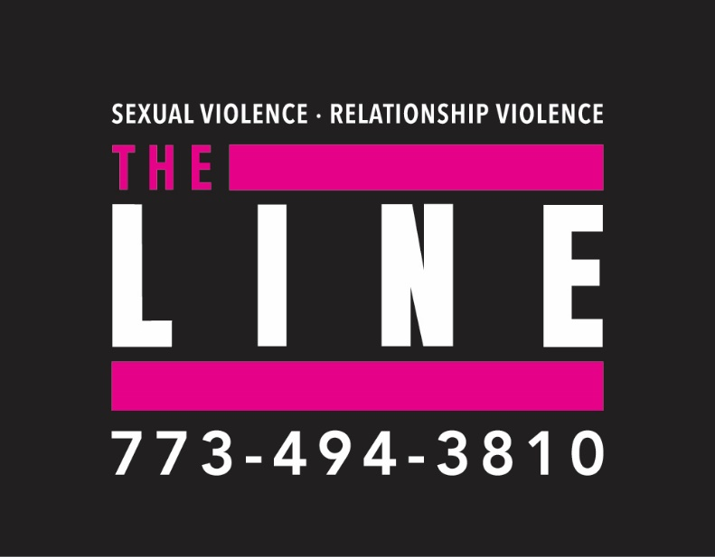

This is Not Your Fault

Healing emotionally after experiencing violence can be a complex process. There is no right or wrong way to react or cope – trust yourself to know what feels right for you. Remember, this is not your fault. No one deserves to experience any form of sexual violence.
Your feelings might feel unsettling or confusing, but they are normal and you are not alone in having them. Some common reactions to traumatic events can include:
- Guilt- we live in a culture that that tends to blame the victim/survivor of sexual violence. No one ever deserves to be assaulted regardless of the situation, what they were wearing, how much they had been drinking, or what they might have consented to previously.
- Fear- it is normal to be scared because you went through something frightening. Many people don’t want to be alone after an assault.
- Avoidance- it is common to not want to think or talk about the assault, which includes not wanting to reach out for support. This can be helpful for many when initially coping with a traumatic event, but many survivors don’t feel that this is an effective long-term solution.
- Anger- anger can be an important part of healing. You might feel angry with the perpetrator, at yourself, at your loved ones, or at the world.
- Distrust- if you are feeling this way, it might take some time to trust people again. If someone assaulted someone you knew, you might lose faith in the people around you or in your own sense of judgement. If it was a stranger, you might find it hard to trust new people.
- Mood Swings- it is common to experience intense moods that change rapidly. This is a difficult thing to deal with and you are likely feeling many things all at once.
- Loss of Control- it is normal to feel powerless after an act of sexual violence. You have been robbed of control over your body and your autonomy. One of the most important facets of emotional healing from this experience is regaining control.
- Numbness- you might not be feeling anything at all. Feeling numb is a common response to a crisis and is a normal part of healing.
Survivors can heal from sexual violence of all kinds, and many survivors find that seeking support from individuals who can form a trusted community is helpful in ensuring a healthy and hopeful recovery process. Be gentle with yourself. If you want to, you can reach out to one of the support systems in your own life or any that you find in this packet.
Adapted from You Are Not Alone: Boston College Resources for Survivors of Sexual Violence

Tips for Survivors on Consuming Media

The media can be a great tool for increasing public awareness about sexual violence, but it can also pose challenges for some survivors. Portrayals of sexual violence in movies, television shows, the news, and social media can prompt negative reactions, from flashbacks and anxiety to feelings of sadness or irritability. There are ways to help limit your exposure to media that could prompt these uncomfortable experiences.
- You are in control of what you see. You don’t have to watch or read something if it is upsetting.
- Pay attention to warnings. Read up on movies or TV shows before watching if you’re unsure.
- Many news stories or shows don’t show the whole story, including the healing process.
- Sharing your story online can be cathartic and empowering, but it can also incite a lot of anxiety or fear. You are not obligated to share your story. It may also prompt unwanted responses.
- Remember news outlets sensationalize stories to attract viewers and they can be biased. You are not obligated to follow every story about sexual assault and it is OK to tune out.
Adapted from RAINN’s Tips for Survivors on Consuming Media

Grounding Techniques

Grounding techniques are especially useful during times of stress, emotional disturbance, and exposure to troubling, disturbing and/or triggering stimuli. These techniques help you reconnect to the present and feel calmer and safer in the here and now. They are based upon evidence-based practices and are used as forms of self-care for a wide range of individuals working to maintain their wellness during overwhelming and difficult experiences.
Techniques you can use in classes or meetings
- Say a safety statement to yourself: “My name is __________; I am safe right now. I am in the present, not the past. I am located in ____________; the date is _____________. What I am feeling right now is valid, but I don’t need it; I can put it away. I am safe right now.” You can also write this to ground yourself. This can be helpful if you are being actively triggered, experiencing disorientation related to trauma, or experiencing another acute stress response.
- Repeat a favorite saying: Have a mantra, quote, or prayer on repeat in your mind that helps calm and soothe you. Positive self-talk can also be helpful. Use these words and their personal meaning to you as a way to ground and soothe yourself.

- Physically ground your body: Dig your heels into the floor, focus on the tension needed in your muscles to do this. Become aware of the pressure on your body of the seat supporting you. Notice how deep breaths into your belly push the small of your back into the chair behind you. Scan through your body and notice what it is in contact with. Continue to focus on deep, long, slow, and “low” breaths that extend into your belly. Let your shoulders and chest remain still as you breathe and try to keep them from rising and falling. Bring your awareness into your body and away from the tension of pain and anxiety.
Additional Grounding Techniques
- Carry a polished stone or soft piece of cloth with you to touch. Hold something that you find comforting and notice how it feels in your hands.
- Eat or drink a favorite food. Enjoy it slowly. Don’t do anything else while you are consuming it except focus on enjoying and savoring it.
- Concentrate on your breathing. Take a deep cleansing breath in through your noise and count. Exhale slowly through your mouth for twice as long. Continue for five minutes.
- Find your pulse on your wrist or neck and count the beats per minute.
- Write in your journal or color in a coloring book. Pay attention to yourself holding the crayon/pencil. Notice the weight and sensation of the pencil in your hand. Listen to the sound of the pencil on the paper.
Adapted from Amherst College Grounding and Self Soothing Techniques and James Madison University’s Grounding Techniques

What to Expect at the Emergency Room
If you were assaulted recently, you may want to seek medical care (even if you do not plan to report the assault). Medical attention can include a physical exam, treatment, and (if you choose) collection of any evidence up to seven days after the assault.
If the assault occurred some time ago, it is still helpful to seek medical treatment for any injuries, infections, pregnancy, or other concerns that you may have. All services in the emergency room are free of charge regardless of how long after an assault you are seeking care.
The Emergency Room Exam
A local hospital emergency room can provide immediate medical attention. The emergency room responds to both the physical trauma of the assault and the process of collecting evidence in case you wish to report to law enforcement. Survivor advocacy services are also available at many Chicago hospitals to provide support, answer any questions, and provide referrals. Please see the list of hospitals included in this packet that will call an advocate upon your arrival at the ER.
Hospitals in Illinois are required to notify the local police department that treatment has been given to a sexual assault survivor. However, you are not required to speak to police or file a police report.
If you wish to have evidence collected, do not bathe, douche or change clothes before the exam. This may destroy evidence. However, evidence may still be collected up to a week after the assault. You may wish to bring a change of clothes with you when you go to the emergency room, since your clothing may be kept as evidence. A sweat suit or scrubs can also be provided to you in many cases.
Evidence Collection
If you choose, the hospital will conduct thorough and complete evidence collection using the Illinois State Police Evidence Collection Kit (the "rape kit"). The entire evidence collection process will be done only with your consent. You may decline any portion of the kit. There is no fee for having a kit done and you do not need to use your insurance.
Evidence may be collected even if you do not plan to report the assault to the police. If you decide at a later date that you would like to file a report, this evidence will be available for 10 years. Any evidence found during the exam may strengthen any resulting criminal court case should you decide to file a report.
Evidence collection is a detailed and invasive process. The doctor or nurse should explain each step of the kit to you. Feel free to ask questions of your advocate if you have any. You can stop the process at any time, decline any portion, or ask to take a short break.

The Cost of an Emergency Room Visit
Should you choose to go to the hospital, you should incur NO COSTS related to treatment for the sexual assault. The Sexual Assault Survivors Emergency Treatment Act (SASETA) will cover emergency room costs, including any medications you receive. The hospital should not bill you for any treatment. If an advocate is present, they can answer any questions related to SASETA and will help to ensure that you are not charged for your treatment.
Additionally, under the Illinois Crime Victims Compensation Act, victims of violent crimes who qualify can be reimbursed for out-of-pocket medical expenses, loss of earnings, tuition, psychological counseling and other expenses due to the crime.
Sexually Transmitted Infections
Sexually transmitted infections (STIs) can be transmitted during a sexual assault. If you are concerned about having an STI, discuss this with the doctor or nurse. They can give you preventive medicine at the time of the exam. You should receive information on any medication given to you. You should get the actual medicine, not just a prescription, in most cases.
Even if you receive preventive treatment, it is important to have follow-up testing for STIs. The Wellness Center can test for most STIs and provide referrals for free and low-cost testing.
Pregnancy Testing
There is a chance that pregnancy could result from a sexual assault. A test for pregnancy is recommended for all people of childbearing age/ability who are sexually assaulted.
You may request a pregnancy test at the time of the exam. However, a test at the time of the sexual assault will not show if you are pregnant from the assault. Follow-up testing is the most reliable way to determine whether you are pregnant. The Wellness Center can test for pregnancy.
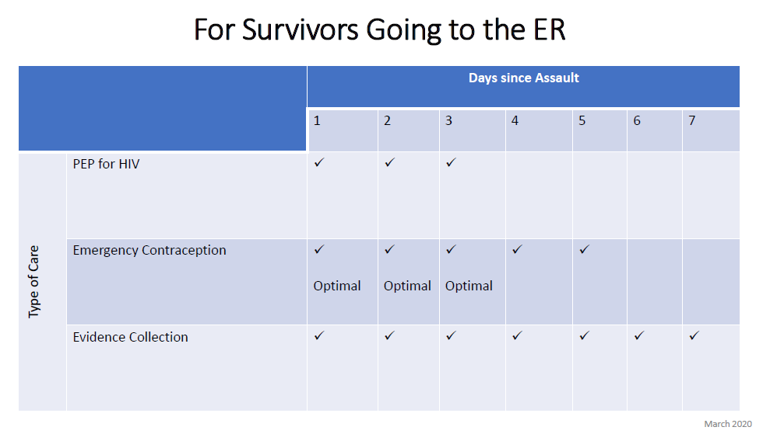
Adapted from After Sexual Assault, Illinois Coalition Against Sexual Assault; and Rape Victim Advocates

Sexual Assault Survivors Emergency Treatment Act (SASETA)
SASETA requires hospitals to provide the following minimum services to sexual assault survivors:
- Respond immediately to the survivor of sexual assault (Code R);
- Examine the patient in a private, closed room without presence of police;
- Provide appropriate tests, x-rays and treatment for injuries sustained;
- Provide patient with a crisis intervention counselor, such as an advocate;
- Test the patientfor sexually transmitted infections (STIs) and for pregnancy;
- Provide patient with necessary medications (antibiotics), not prescriptions;
- Directly bill the patient’s’s public or private insurance carrier or the Illinois Department of Public Aid, if you have no insurance information. Under no circumstance should the survivor be billed for outpatient hospital charges, medication, or ambulance emergency care of transportations.

Crime Victim’s Compensation Information
You may be eligible for crime victim’s compensation through the Attorney General’s Office if:
- You are a victim of a violent crime and sustain physical injuries;
- You are the dependent of someone who died as a result of a violent crime;
- You report the crime to the proper authorities within 72 hours and cooperate fully with law enforcement officials;
- Injury or death was not attributable to wrongful conduct or provocation;
- You are related to the victim and pay reasonable medical and/or funeral expenses.
Contact Resilience’s legal advocacy department for assistance in filing for compensation at 312-663-6303, or you can call the Attorney General’s Office at 1-800-228-3368.

Victims Economic Security and Safety Act (VESSA) of 2003
In accordance with the Illinois Victims Economic Security and Safety Act (VESSA) of 2003, leave shall be granted to an employee who is a victim of domestic or sexual violence or who has a family or household member who is a victim. Family or household member means a spouse, parent, son, daughter, and persons jointly residing in the same household. Parent means the biological parent of an employee or an individual who stood in loco parentis to an employee when the employee was a son or daughter. Son or daughter means a biological, adopted, or foster child, a stepchild, a legal ward, or a child of a person standing in loco parentis, who is under 18 years of age, or is 18 years of age or older and incapable of self-care because of a mental or physical disability.
All employees are eligible for up to 12 workweeks of leave during any 12-month period (depending on size of the company). All employees are entitled to at least 4 weeks of leave under VESSA. The initial 12-month period is measured forward from the date the employee first takes VESSA leave. The next 12-

month period begins the first time VESSA leave is taken after completion of any previous 12-month period. This Act does not create a right for the employee to take a leave that exceeds the leave time allowed under, or in addition to, the leave time permitted by the Family and Medical Leave Act. For employees on VESSA leave who are also eligible for FMLA leave, VESSA leave time is not in addition to the 12-week FMLA entitlement when the reason for VESSA leave also qualifies under FMLA, but depletes the 12-week FMLA entitlement when used. An employee who may have exhausted all available leave under FMLA, for a purpose other than that which is available under VESSA, remains eligible for leave under VESSA.
An employee shall be entitled, on return from leave, to be restored to the position held by the employee when the leave commenced, or to an equivalent position with equivalent benefits, pay, and other conditions of employment.
Domestic or sexual violence means domestic violence, sexual assault, or stalking. Domestic violence includes acts or threats of violence, not including acts of self-defense, as defined in subdivision (3) of Section 103 of the Illinois Domestic Violence Act of 1986, sexual assault, or death to the person, or the person’s family or household member, if the conduct causes the specific person to have such distress or fear. Sexual assault means any conduct proscribed by the Criminal Code of 1961 in Sections 12-13, 12- 14, 12-14.1, 12-15, and 12-16. Stalking means any conduct proscribed by the Criminal Code of 1961 in Sections 12-7.3 and 12-7.4.
Illinois Department of Labor, 2023

Wellness Center Services
The Wellness Center provides high quality interdisciplinary medical, mental health, and health promotion services that enable our diverse student population to more fully participate and succeed in the college experience. By enhancing health and wellness, within the context of a Jesuit Catholic institution, each student is empowered to take responsibility for self-care by making informed lifestyle choices that contribute to their own success and to the well-being of the community. At Loyola's Wellness Center, you will find medical, mental health, and health education professionals committed to your well-being. Together, we work to create a strong, safe campus community so that every Loyola experience is successful.
Staff
The professional staff at the Wellness Center includes registered nurses, nurse practitioners, physicians, social workers, psychologists, psychiatrists, a lab technician, health educators, gynecologists, advocates, and a registered dietitian. In collaboration with faculty, graduate student interns in psychology, nursing, social work, and dietetics complete clinical rotations at the Wellness Center.
Confidentiality
All consultations and records are strictly confidential and are not released without the student’s written consent.
Services and Programs
Assessment, treatment, guidance, and support are available to help students enhance their well-being and to manage common medical and mental health issues. Students visiting the Wellness Center with chronic illnesses or serious injuries may be referred to specialists or local hospitals for specialized care. Wellness Center services and resources include diagnosis and treatment of common illnesses, lab tests, immunizations, health education programs, mental health counseling, canine therapy, prescriptions, referrals, women’s wellness exams, and more. Telephone advice is available through the Dial-A-Nurse service by calling 773.508.8883. The Wellness Center offers various interactive programs and support groups on topics like stress management, healthy relationships, alcohol, meditation, emotional wellness, and nutrition.
Location
The Wellness Center has locations at both the Lake Shore Campus and the Water Tower Campus. The Lake Shore Campus Wellness Center is located at 6439 N. Sheridan Rd., Suite 310. The Water Tower Campus Wellness Center is located at 26 E. Pearson., Terry Student Center Suite 250. The Health Sciences Campus Wellness Center is located at 2160 S. 1st Ave, Cuneo Center Suite 400.

Eligibility and Fees
Students currently attending classes (full- or part-time) are eligible to use the services provided at the Wellness Center at no charge. Students taking less than seven credits per semester are eligible for Wellness Center services after paying a fee. Some lab tests, immunizations, prescription medications, and materials are provided at an additional fee. Students are responsible for all health care costs outside the Wellness Center.
Depression
Some students may feel overwhelmed at times and experience anxiety and depression. Students experiencing symptoms of depression, or that know another student who might be, can seek help by contacting the Wellness Center.
Alcohol
The University expects students to follow Illinois state law and Loyola’s alcohol policy, which are both enforced. However, students are young adults who have the freedom and responsibility to make their own decisions, and they often consume alcohol even when it conflicts with the law. The Wellness Center offers prevention education programs and interventions to students in an effort to help them make safe, responsible decisions about alcohol.
Sexual and Relationship Violence
Loyola strives to make this community one where intimate partner violence and domestic violence, stalking, and sexual assault are not tolerated. Loyola also continues to make this a place where students who experience these types of violence have support. Students can call The Line at Loyola (773. 494.3810) to find out how to be connected to services on and nearby campus, navigate reporting options, and get needed support.

For more information about the Wellness Center including hours, services, and programs, a student self-care guide, events, and more, visit The Wellness Center’s website.

Loyola’s Policies Regarding Sexual Misconduct

Sexual misconduct is against Loyola’s policies. The specific policy can be found here:

- Comprehensive Policy and Equitable Resolution Procedures for Discrimination, Sexual Misconduct, and Retaliation
  - In particular, see Article 1, Section VIII(B) “Sexual Misconduct” and Article 3, Section I(A) “Title IX Sexual Harassment”

For more information on Title IX, please visit the Title IX section of Loyola’s website.

To file an official report with the University about sexual misconduct, or learn more about reporting options, visit the Office of Equity and Compliance website.

Off-Campus Resources

If you want access to services outside of Loyola or more culturally-specific resources, below is a list of organizations that are available to help you.

Chicago Rape Crisis Hotline
1-888-293-2080 | https://ywcachicago.org/our-work/sexual-violence-support-services/
Operating 24 hours a day, 7 days a week, the Rape Crisis Hotlines provides survivors of sexual violence and their significant others immediate support, crisis intervention and referrals for the city of Chicago.

Resilience (formerly Rape Victim Advocates)
312-443-9603 | www.ourresilience.org
Crisis intervention, medical and legal advocacy, and trauma therapy services are available to anyone in need of support in the Chicagoland area. As an independent rape crisis center and not-for-profit organization, they partner with local hospitals and organizations to deliver services 24 hours a day, seven days a week.

Chicago Alliance Against Sexual Exploitation (CAASE)
773-244-2230 | www.caase.org
The Sexual Assault Justice Project (SAJP)
Their attorneys are available to meet with you confidentially to provide individualized legal advice, consultation, and representation following and related to sexual assault. They tailor their services to the needs of individuals and serve survivors of every sex, race, socio-economic status, ability, sexual orientation, gender identity, nationality, and immigration status. All of their legal services are free, regardless of income.

Porchlight Counseling Services
773-750-7077 | www.porchlightcounseling.org
Greenlight counseling exists to help survivors achieve healing and wholeness and to create a world in which a person’s life is not defined by the experience of sexual assault. Greenlight provides counseling, advocacy, and other services to student survivors of sexual assault. It is Greenlight’s goal to provide high-quality, long-term counseling at no charge to the client.

Center on Halsted Anti Violence Project
773-871-2273 | http://www.centeronhalsted.org/AVP.html
AVP at Center on Halsted provides comprehensive individual and community programs for survivor advocacy and support to LGBTQIA survivors of hate and bias violence, discrimination, intimate partner violence, stalking, and/or sexual assault. If you or someone you know has experienced violence, threats, or intimidation AVP can work with you to help ensure your safety and provide the support you need.

Resilience Hospital Contact List

Advocate Illinois Masonic Medical Center
836 W Wellington Ave. Chicago, IL 60657
Emergency Department: 773-296-7078

AMITA Health Resurrection Center Chicago
7435 W Talcott Ave. Chicago, IL 60631
Emergency Department: 773-774-8000

Cermak Hospital located in the Cook County Jail
2800 S California Ave. Chicago, IL 60608
Emergency Department: 773-674-7488

Community First Medical Center
5645 W. Addison St. Chicago, IL 60634

John H. Stroger, Jr. Hospital of Cook County
1969 W Ogden Ave. Chicago, IL 60612
Emergency Department: 312-864-1300

Mount Sinai Hospital
1500 S Fairfield Ave. Chicago, IL 60608
Emergency Department: 773-257-6241

Northwestern Memorial Hospital
251 E Huron St. Chicago, IL 60611 (entrance is located on Erie St.)
Emergency Department: 312-926-5188

Provident Hospital of Cook County
500 E 51st St. Chicago, IL 60615
Emergency Department: 312-572-1700

Rush University Medical Center
1653 W Congress Parkway Chicago, IL 60612
Emergency Department: 312-942-4978

Saint Joseph’s Hospital
2900 N Lakeshore Dr. Chicago, IL 60657
Emergency Department: 773-665-3086

Saint Mary of Nazareth Medical Center
2233 W Division St. Chicago, IL 60622
Emergency Department: 312-770-2418

Swedish Covenant Hospital
5145 N California Ave. Chicago, IL 60625
Emergency Department: 773-989-3800

Thorek Hospital
850 W Irving Park Rd. Chicago, IL 60613
Emergency Department: 773-975-6770

University of Illinois Hospital (UIC)
1740 W Taylor St. Chicago, IL 60612
Emergency Department: 312-996-7279

Weiss Memorial Hospital
4646 N Marine Dr. Chicago, IL 60640
Emergency Department: 773-564-7500

West Suburban Medical Center
3 Erie Ct. Oak Park, IL 60302
Emergency Department: 708-763-6747

Resilience, 2023

